Computer Organization and Assembly Language Lab

Project Report
Session: Fall 2024
Submitted By:
Muhammad Ayan Sajid | 2024-CS-661
Muhammad Husnain | 2024-CS-696
Fiza Shahid Khan | 2024-CS-680
Shareen Asim | 2024-CS- 693
Abdul Hadi | 2024-CS-655
Submitted To:
Mr. Noman Munir
Department of Computer Science, UET Lahore, New Campus
Table of Contents
1 Problem Statement 3
2 Program Architecture & Modular Design 3
3 Implementation of Assembly Language Concepts 3
3.1 Bit-Level & Security Operations 3
3.2 String Processing 3
3.3 Numeric & Data Processing 4
3.4 Input/Output & File Handling 4
4 Register & Memory Usage 4
5 Program Flow (Flowchart summary) 5
6 Test Cases & Debugging Evidence 6
6.1 Output Screenshots 7
7 Conclusion 9

Table of Figures
Figure 1 Flowchart 5
Figure 2 Authentication & Main Menu interface 7
Figure 3 Playing the game (showing character replacement and hints) 8
Figure 4 Game Over screen (showing Math/Average calculations) 8
Figure 5 Array Traversal (Option 3: View Score History) 9

Problem Statement
The objective of this Open Ended Lab (OEL) was to design and implement a menu-driven assembly language toolkit combining numeric data processing, string handling, and bit-level security operations. The system processes datasets, manages user interactions, and securely saves data using standard low-level programming concepts (registers, memory variables, arrays, string buffers, macros, and file I/O) via the MASM Irvine32 environment.

Program Architecture & Modular Design
To ensure high code quality and testability, the project implements a strict modular design across five files, utilizing PROTO and EXTERNDEF for linking:
- globals.inc: Acts as the shared header. Contains the Start_level and Reset_Str macros, global variables, and procedure prototypes.
- main.asm: Handles boot-sequence file loading, user menu interactions, and conditional branching.
- auth.asm (Security Utility): Handles user authentication, bitwise encryption, and .txt file I/O.
- hangman.asm (String Processor): Manages the 10-level word guessing game, string primitives, dynamic memory modifications, and string reversal.
- results.asm (Numeric Analyzer): Calculates averages, maintains maximum scores, tracks history via DWORD arrays, and manages binary .dat file I/O.

Implementation of Assembly Language Concepts

Bit-Level & Security Operations
The authentication module encrypts passwords using a combination of XOR masking and Bitwise Rotations (ROL/ROR).
- Encryption: XOR AL, 5Ah followed by ROL AL, 1.
- Decryption: ROR AL, 1 followed by XOR AL, 5Ah.
The encrypted bytes are stored directly into password.txt, ensuring the raw password is never visible in the file system.

String Processing
- Case Conversion: User input is converted from lowercase to uppercase using the bitwise operation AND AL, 11011111b.
- String Reversal: If the user fails a level, the actual word is printed backwards using a loop with the ESI and EDI registers.
- Memory Reset: Between games, the macro Reset_Str utilizes the string primitive REP MOVSB alongside the CLD flag to rapidly copy clean template strings over the modified hidden string buffers.

Numeric & Data Processing
- Averages & Limits: The score calculation utilizes the MUL and DIV operations: Average = ((Avg * Rounds) + New Score) / (Rounds + 1).
- Array Handling: A session history array (score_history DWORD 100 DUP(0)) is populated using scaled-index addressing (score_history[EBX * 4]) to log up to 100 round results.

Input/Output & File Handling
The project implements persistent storage.
- Uses OpenInputFile, ReadFromFile, and WriteToFile APIs.
- High scores are securely stored as raw 32-bit registers (4 bytes) inside a binary file highscore.dat.

Register & Memory Usage
Register | Primary Usage in Project
EAX | Standard I/O (ReadInt/WriteInt), math accumulator, returning File Handles.
EBX | Array index scaling (EBX * 4) and storing File Handles during I/O.
ECX | Loop counters and tracking the exact number of missing letters in strings.
EDX | String offset pointers for WriteString and CreateOutputFile.
ESI / EDI | Source and Destination pointers for string arrays and REP MOVSB macros.

Program Flow (Flowchart summary)
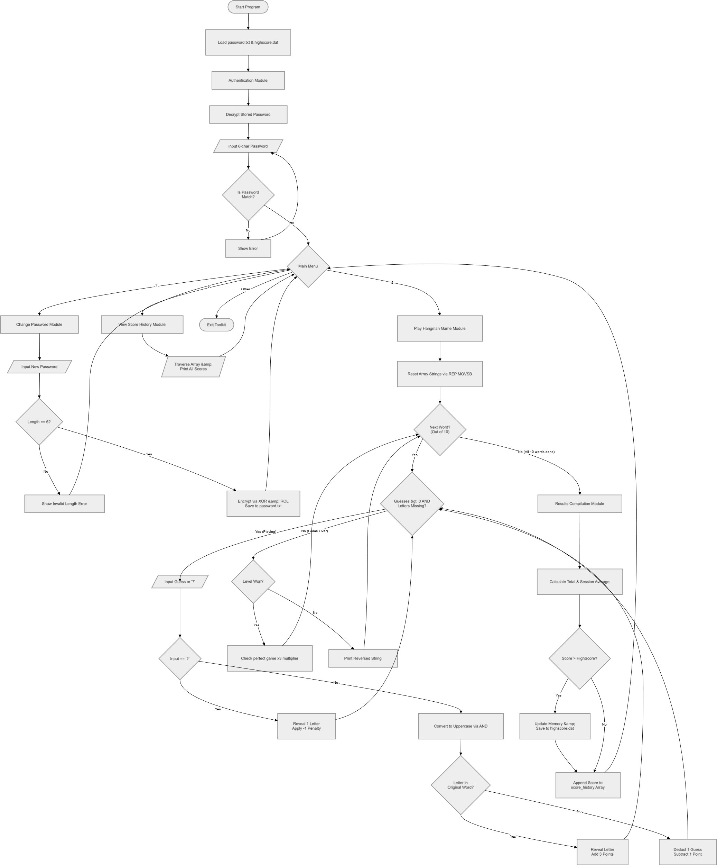
Figure 1 Flowchart

- Boot: Program loads password.txt and highscore.dat into .data memory.
- Auth: Prompts user for 6-character password. Compares using REPE CMPSB.
- Menu: Allows selection between (1) Change Password, (2) Play Game, (3) View History, (4) Exit.
- Game Loop: Loads template strings. Takes character input -> Bitwise uppercase conversion -> Array search -> Updates hidden string -> Updates numeric score.
- Post-Game: Checks if Score > High_Score. Saves to file. Appends score to score_history array. Returns to Menu.

Test Cases & Debugging Evidence
Test Case | Input | Expected Output | Actual Result
Invalid Auth | "999999" | "Incorrect Password! Try again." | Passed. Denied entry.
Valid Auth | "123456" | "Authentication Successful!" & Menu opens. | Passed.
Change Password Length | "123" | "Invalid password! Must be exactly 6 characters." | Passed. Handled boundary case.
String Case Handling | Guess lowercase 'a' | Safely converts to 'A', matches array, reveals letter. | Passed.
Hint Feature ('?') | Input '?' | Deducts 1 pt, removes x3 multiplier, reveals 1 letter. | Passed.
Level Failure | 5 wrong guesses | Shows "Failed" and prints word reversed (String Reversal). | Passed.
Score History Array | Press '3' in Menu | Prints "Game 1: [Score]", "Game 2: [Score]". | Passed. Array traversal correct.
Data Persistence | Restart App | High score and changed password persist perfectly. | Passed. File I/O operational.

Output Screenshots
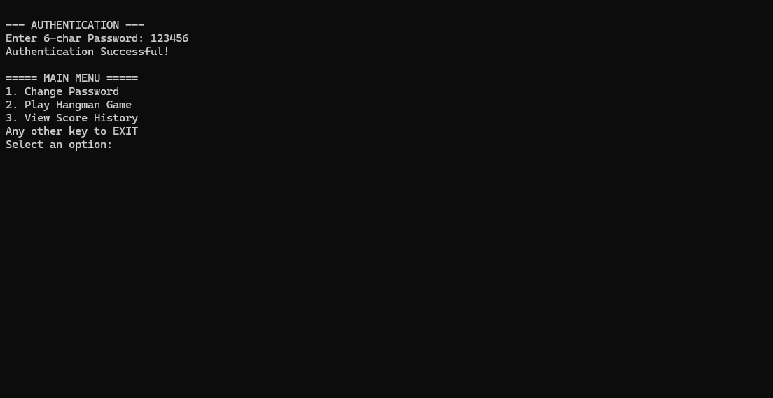
Figure 2 Authentication & Main Menu interface
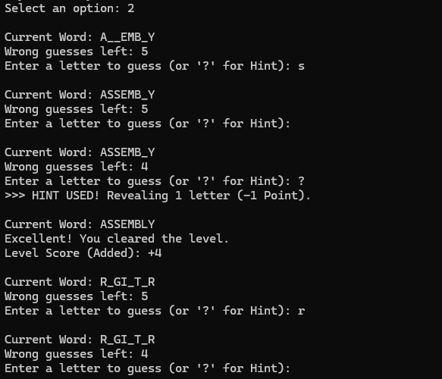
Figure 3 Playing the game (showing character replacement and hints)
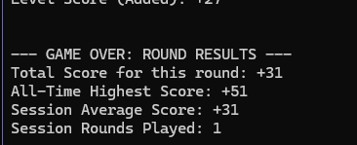
Figure 4 Game Over screen (showing Math/Average calculations)
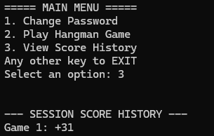
Figure 5 Array Traversal (Option 3: View Score History)

Conclusion
This project successfully fulfills the requirement of the CSC205L Open Ended Lab by deploying an advanced, fully modular Assembly Language application. It heavily utilizes low-level data tracking, memory buffering, bitwise security, numeric mathematics, and file streaming to create a stable, crash-free user experience.

